Casey Bladow

Engl. 387 Fall ‘13

Technical Procedure

11/9/13

**How to Build a PC from Scratch**

**Introduction**

This Technical Procedure describes how to assemble a PC and prepare it for an OS (Operating System) installation. The information is intended for use by any reader so that they can build a PC with basic PC knowledge. The major stages of this procedure are represented in Figure 1 below.

Figure 1: Major stages of PC assembly

Building a computer from the ground up gives you the exact machine that best suit your needs, but this process can be very daunting the first time around. Before we jump too deep into this I will be explaining a little bit of computer hardware basics.

Anyone could run to the store and just purchase a PC, but you may find that you’re happier with a custom built machine. Building a PC from the ground up enables you to craft it perfectly to your needs, whether you’re a hardcore gamer, video editor, or you’re just a college kid trying to build something for schoolwork. In some cases, you may save a little money, but in all cases you will have finished a project that you can use for years. It should be pretty obvious that building a computer is far more time consuming than just buying one.

**The Parts That Make Up a Computer (and What They Do)**

**The Processor**

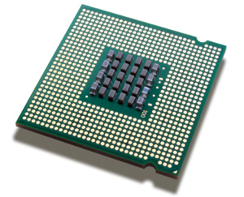The Processor (CPU – Central Processing Unit) is truly the “brain” of your computer; it carries out every task that you give it. The more advanced of a CPU you have the more it can process at a single time, and process those tasks faster. Unfortunately most people don’t take full advantage of processors full speed, so the high-end models are really only crucial if you’re performing intensive tasks like gaming, video editing, or compiling code. This part tends to be the most expensive piece of the machine, so if you’re not performing intensive tasks, don’t worry about buying the latest and greatest.

**The Motherboard**

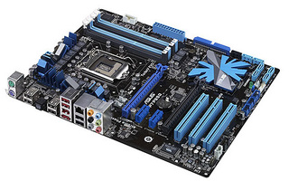The motherboard connects all the other components together. It’s the physical base that you build everything on. It contains most of your machine’s core features, like the number of USB ports, and how many expansion cards you can put in (video card, sound, Wi-Fi). The motherboard you choose will decide if you are building a low, medium, or high performance machine. This part can typically be bought as a bundle with a compatible CPU.

**The Case**

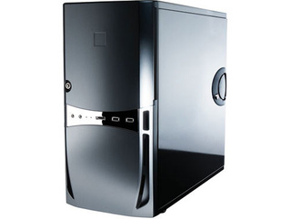The case is what holds all of your computer parts together. For the most part, the case doesn’t offer many features that affect how the computer runs but is more about features that affect you. The case plays a big role in how quiet your computer runs, obviously how large your computer is, and how it looks in your room or office.

**The RAM**

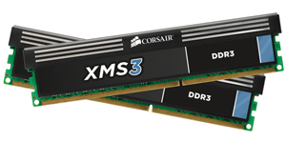RAM (Random Access Memory) is a lot like the computer’s short term memory. It stores data your computer needs quick access to to help your programs run faster, and help you run more programs at once. So, if you’re looking to run a lot of programs at once, you’ll want to make sure you have enough RAM to do so. If you are a fan of virtual machines, you’ll want even more RAM.

**The Graphics Card**

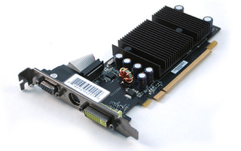The Graphics card (GPU) is a processor specifically designed to deal with graphics. It’s what you plug your monitor into. Some motherboards come with a GPU already built in, which is enough to manage your desktop but typically not enough to power intense gaming or high definition video playing. For jobs like those you will want to look into spending the extra cash and having a dedicated graphics card.

**The Hard Drive (or Drives)**

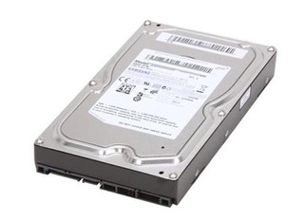Your hard drives store all the data, literally, everything. It stores the OS that you installed to your documents, music and movies. If you think back to the RAM being the short term memory, you can think of the Hard Drives as being your computers long term memory. The kind of hard drive you choose will determine how much data you can store, if you decide to go with a solid state drive, your computers speed can even be affected.

**The Optical Drive**

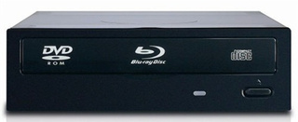An optical drive (CD or DVD drive) is what your computer uses to read CDs, DVDs, or Blu-Ray discs. They’re not necessary for every computer but you can usually pick one up for $20 so it doesn’t hurt to have one.

**The Power Supply**

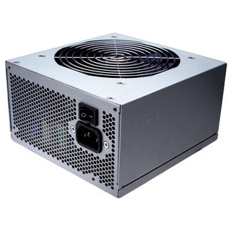The power supply directs electricity to the other components in your machine. The power supply you buy will greatly depend on whether or not you are building a high or low end PC. If you have a fast CPU, GPU and a few hard drives, you are going to want a power supply that puts out enough wattage to handle all that. This can generally be the last item you shop for because you have now nailed down all your other parts and know how much electricity they will require.

So you’ve gathered up all your parts and tools are ready to get started. Assembling a computer can seem daunting at first glance, but in the end you’ll see it’s actually pretty easy. Let’s get started…

**Step One: Mount Your Motherboard**

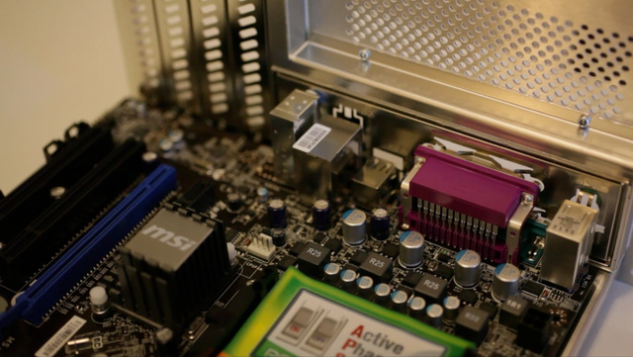

Opening the case should be incredibly simple, usually only requiring a few thumb screws to unscrewed from the back of your case and sliding the side panel off. Take a good look inside your case and note where certain things are. You can see where the hard drive bays are, where the CD drive will go, where your power supply mounts and so on. There should also be a bag of screws inside your case, grab that and set it aside for now.

Open up your motherboard box and take out the I/O shield (the metal plate that protects the ports on the back of your motherboard). There should be a pretty noticeable rectangular space in the back of your case where this should snap into place. This can take a little bit of force but is incredibly important, so make sure that all four sides are snapped in securely.

Next, pull out your motherboard and line up the ports on the back with the I/O shield. You should notice that the holes in the motherboard will line up with the screw holes on the bottom of your case. There are probably more holes in your case than are in your motherboard, note which ones these are, and grab the motherboard standoff screws from the bag. Standoff screws are the ones with a male screw on one end and a female end on the other. Screw these standoffs into those holes, and set your motherboard on top of them. Screw your motherboard screws into the standoffs so that the motherboard is snugly mounted.

**Step Two: Install Your Processor**

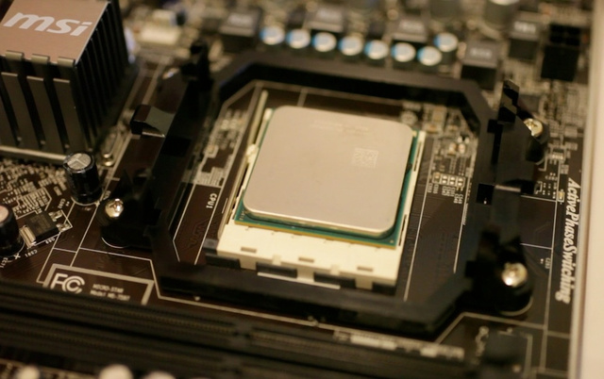

Open up your CPU’s box and very gently take it out. The CPU is one of most fragile parts of the build, so this is one step that requires you to be extra careful. One of the corners on your CPU will have a gold corner, find it. Now look at your motherboards CPU socket for a similar arrowed corner, find it. Line up these two arrows and carefully drop the CPU into the socket. This HAS to be absolutely correct or you run the risk of bending pins and your CPU will be shot.

Lift up the lever on the CPU socket and put CPU in. Pull the lever down to lock it into place. Again, do this with extra caution. It shouldn’t require any strength of force at all, so if it’s not falling into place with ease, you are doing something wrong. Take it out and try resetting it, make sure the two corners are lining up, and of course, double check that your motherboard and CPU are of the same socket type.

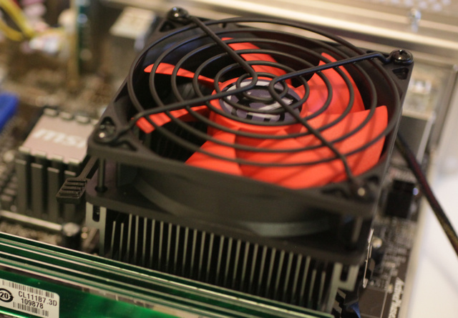

Once your CPU is in, grab the fan and cooler it came with. It should already have some silver thermal paste on the bottom. If not, you will need to buy some from any computer store and apply a very thin line on you CPU.

Place the cooler on top of you CPU. This can take a few tries to get right but you can find more info on how this is done in your CPU’s manual.

**Step Three: Install Your RAM**

Installing RAM is very simple. Find the RAM sockets on your motherboard, and pull the two clips on the side down. Line up the notch in you RAM stick to the notch in the socket and press the RAM down into the space. This may take a little extra pressure but if done right the clips will snap into place when the RAM is fully in the socket.

**Step Four: Install Your PCI Cards**

Your video card and any other PCI expansion cards you have are installed now. Find the topmost slot that fits your card and match that up with its plate on the backend of the case. Remove that plate so when the cards installed you have access to its ports. Cards should be pretty easy to install from this point, simply place them on the slot and push them down. Finish it by screwing the bracket onto the case.

**Step Five: Install Your Hard Drive**

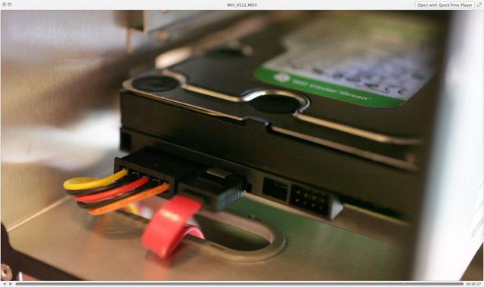

Every case has its own way of installing these. Generally, there are two methods: on some cases, you have to pull out a hard drive tray, screw the drive in, and then slide it back in. Other ones just require you to slide the bare drive into the bay and then screw it in snug after the fact. A quick look into you case’s manual can give you the specific details you are looking for here.

If you are using multiple hard drives and a big case, it is a good idea to leave a bit of open space around them. This will allow better airflow between them and keep them running cool.

**Step Six: Install Your Optical Drive**

This is pretty self-explanatory. Just pull out the plastic cover on one of your 5.25” drive bays and slide in your optical drive. If necessary, screw it into place.

**Step Seven: Mount Your Power Supply**

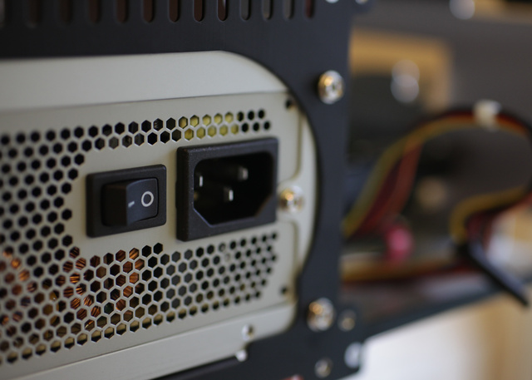

This is a step you may be able to skip. If you bought a case that has power supply already in it then you obviously don’t have to worry about this. You should have everything else installed now so it’s time to install its power and start plugging things in. it should be fairly obvious where this goes, as there will be a big rectangular hole in the back of the case. Some cases mount these on top while others mount them on the bottom. Regardless of that, they will mount with the fan facing away from the edge of the case.

Once you set it into place, you should see the holes on the back of the case line up with the screw holes in the power supply. Screw it into place.

**Step Eight: Plug Everything In**

This will be the most tedious and difficult part of the process. Separate the cords coming out of the power supply and plug them in individually.

The 24-pin Motherboard Cable is the biggest cable on the power supply. It is what gives power to the motherboard. It has very long plug with 24 little pins in it. This will snap right into place on the motherboard and make a clicking sound when done successfully.

You should also see a separate 4-pin cable coming out of the power supply, look for the small 4-pin socket on the motherboard and snap this one into place. Just like the 24-pin cable, this will snap and lock into place.

If you have a rather powerful graphics card, you may also need to plug a cable from the power supply into it. Look for a 6-pin PCI cable. It looks similar to the 24-pin and 4-pin cables.

Your hard drives and optical drives will plug using SATA cables. One of the cables comes from the power supply and is skinny and black, the other is a red cable that should have come with your motherboard. This SATA cable replaces the old method of IDE cables and transfers the data between the drives and motherboard. The sockets are L-shaped, so they’ll only go in one way. After you have everything plugged in on that end connect the SATA cable to the motherboard via a socket labeled SATA. Repeat this process for your optical drives.

You will now find some Molex power cables. These are used to power miscellaneous things in your build (case fans). Take these plugs and connect them to the appropriate female plugs from the power supply. Note that some fans (CPU fan) may have a smaller connector that actually plugs into your motherboard instead of the power supply. There will be small headers labeled CPU_FAN or SYS_FAN if this is the case. This is intended so that a program may be able to control the speed of this fan.

Most cases have some ports on the front (Front panel audio, USB, headphone jack). You should see small cables coming from the front panel that will plug into ports on the motherboard. These can be tricky to find as they are super small.

Finally, you should have a few cables labeled POWER SW, RESET SW, HDD LED, and a few others. These also connect to the motherboard with corresponding labeled ports.

**Conclusion**

Your computer is ready to be plugged in and turned on. If this procedure has been followed correctly, it is time to plug in a mouse, keyboard, and monitor, slip in an OS disc and install that OS.